6A^{th} Grade: Unit 7, Lesson 4

- To determine the area of a trapezoid or a rhombus, they can each be decomposed into what?

Triangles

- A quadrilateral with measurements in centimeters (cm) is shown. What is this quadrilateral?
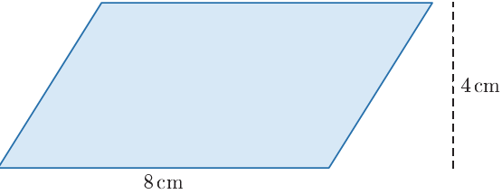

A parallelogram

- A triangle is a polygon with 3 sides and how many vertices?

3 vertices

